# CHAPTER 1

# GENERAL INTRODUCTION

This chapter provides an introduction of” Online Village Security Contribution system” within which aims at describing the background of this study, problem statement, objectives of the study, research questions, scope of the project, significance of the project, limitation of the project and the organization of the project. This Village Security commonly known as Irondo is a home grown solution where gigantic and determined men organize themselves in groups and patrol their neighborhoods especially at night.

However, these courageous young men still need basic life treatments to better accomplish their duties, which leads to the better methods of paying and management of their environment; this is where ICT along with community policing can provide an incredible solution whereby it becomes easy to recruit them by use of mobilization of community policing and provide them with money collected and forecasted from villagers contribution by using ICT system without forgetting that communication amongst them also becomes straightforward.

## Background of night patrol in Rwanda (IRONDO)

Rwanda has been known for its tremendous security in Africa whereby it is ranked in the safest countries of the continent because it has been seen that Rwanda is safe and sovereign in the country inside it is now at the point of exporting this security where many of the defense and police go in other countries for peace keeping missions.

However, before going for peace keeping the Rwanda itself had to be secure in every area this is why the security enforcement is started at the village level and this could not achieved by the police working on its own in an efficient productivity so they initiated IRONDO operated by young men who are courageous enough to stand against thieves and anyone who is willing to hurt the villagers, this system has been put in place since 2014 and they report to the sector level but the initiative is from the Rwanda National Police in the department of community policing

## Statement of the problem

These young men in Irondo are doing an impressive work appreciated by every Rwandan, however good it is, there are still issues concerning how the payment is raised or collected.

The currently system used in collecting money from villagers to pay this Irondo involves that an appointed individual moves through the whole village, house by house, day per day so that he may be able to have these contributions from each household by time, and this is incredibly painful since every payer will not have money at the exact moment that the collector will be coming so it may force the collector to reach the same house for a once collection for three or four times or if he simplifies this same cycle and decide to call the payers before attaining them it will still cost him a lot of call fees to reach every villager over phone.

On one side, the collector of money is forced to move across same cycle while receiving theses contributions but also on the other side, a payee may have the money for contribution right away but since the system does not facilitate the ease of payment he ends up waiting for when the collector will move through the whole cycle and return back to him whereby often the collector reaches the payer aftermath of money consumption.

Lastly, we may not leave behind how managing the contributions and calculations in papers is another issue because you are not able to have a number to base on and predict about the contributions in months to come also this system complicates counting of permanent or recording/removing every new resident.

## Objectives

This study has general and specific objectives as they are stated in the following subsections:

**General objectives:**

The main objective of this study is to design and implement a Village security contribution Management system which helps the payer, collector and the village leaders to interact and have access to information they need using this platform

**Specific objectives:**

* To understand and to know how the current contribution collection system is done.
* Develop an application which will bring solutions to the above-stated problems
* To design a system which will reduce the time taken by resident and collector in order to get a ride on their contribution plan
* To design a system that will help every resident to know which month and how much to pay with detailed guide.

## Research Questions

* How do you record the data in your everyday services? This went to contribution collector.
* How do you feel about payment methods for contribution? This went to residents
* When managing all contributions by using papers and how faster are you recognizing all resident’s overdue, surplus, debts based on months?
* What do you think could improve you work and get a report on time or easier way? this went to the village leaders.

## Motivation

I am very proud of how Rwanda is treated on the global scale this is mainly relying on the security found in the country inside which allows trade and every other institution to strengthen and leads to the overall country development.

Since recognition of this I have been eager to contribute my part to this whereby I believe that as IT student by implementing this type of project am capable of taking the community policing_ Irondo to another tremendous level that both locally and internationally recognized.

## Project scope

This project is based on managing contributions given by residents at a village level. It will the data handling easier. It shall also help collector to find residents who requests to pay and access his information of how to get in touch in a timely period. I cannot leave behind that all information needed by the payer will be found on a one stop location where also the village leaders who are concerned with making financial decisions will easily have a touch on this information.

**Time scope**

Online Village Security Contribution System is wide task and needs a lot of effort to be accomplished. According to the features to be implemented, time for it to be completed is 3 months, From August 2019 to November 2019.

### Geographical scope

This project shall be used by any village located in Rwanda, in any province; by having its own account on the system.

### Content scope

At Village level in Rwanda there are many activities that can be computerized like residents who attended Umuganda, those that paid the cleaning services and so many others but due to the budget and time constraints my project will focus on online Security Contribution management system.

## The interest of the project

The main interest of the project is to strengthen our skills to build our confidence in information technology professional and to prepare for a future profession career. The interest of this project is categorized into personal, institutional and community interests.

### Personal interest

Developing and implementing is the best opportunity to apply the knowledge acquired during last three years of study in the University. I gained the professional skills especially in project management and software development. This skill was helping me in future career. It will strengthen my capacity of solving the problems found in community and come up with strong solution.

### Institutional interest

Since recognition of how Rwanda is treated at global level due to its remarkable security, I have been eager to contribute my part to this whereby I believe that as IT student by implementing this type of project am capable of taking the community policing_ Irondo to another tremendous level that both locally and internationally recognized

Not to forget that by developing this system will help UOK learners in their research process this is because that what I am doing will be kept in the UOK library so whoever will read this shall gain more insights

**Public interest**

The public interest can help citizens to pay easily without difficulties of finding the collector in person and this will reduce waiting time, saves resources expenses and increases the village’s collections on monthly basis. Also enables the easiest way to make calculations to find the debts and surplus.

## Limitations of the project

To developing this system wanted to complete it quickly and go deeply as much as possible, but the following are limitations that I am facing while implementing. Lack of full access to the residents’ profiles and records such as National identities, Ubudehe classes and other related data; this would help me to make something realistic not targeted to the academic affairs. Lack of enough information. We as Rwanda use to hide information this accuse while gathering information for stance asking somebody the way things are but they give no answer.

## Organization of the project report

This project report is divided into five chapters:

Chapter one,(Introduction to the study)presents the background of the study, statement of the problem, purpose of the study, research objectives, research questions, scope of the study, significance of the study, limitations of the study.

Chapter two, (Literature review) provides a review of related literature to the problem under study that is: ‘Village Security Conrtibution management system’, review of the existing system, the conceptual framework, critical review of the existing system and the proposed system.

Chapter three, (Research design and methodology) provides a research methodology and design. Included under this chapter are: research design; target population; sample size; sampling procedure; research instruments; data collection; data analysis.

Chapter four,(System analysis, design and) presents an System Study, System Analysis, Systems Design, System implementation, System testing and validations are discussed under the headings drawn from the objectives of the research.

Chapter Five, (Discussion, conclusion and recommendation)provide a discussion, conclusion and recommendation based on the major findings of the study.

# CHAPTER TWO: LITERATURE REVIEW

## Introduction

As literature review is a text of a scholarly paper, which includes the current knowledge including substantive findings, as well as theoretical and methodological contributions to the topic.

The goal of this chapter is to provide the background information, definition and an overview on concept for selected methods and technology which served as guide to the development of this project .It also provides the meaning of the useful terms used in this project for helping the user to understand this project.

This chapter is made by 3 parts:

First part provides the description of terms that are related to the research topic and technical terms related to the method used for implementing this project.

The second part focuses on comparative studies; it means research done in order to get solution to the identified problem.

The last part of this chapter focuses on our contribution to solving the identified problem.

## Review of past studies on Village management system

**Review on operations of village security IRONDO**

Rwanda as a country that has always found solutions to its problems through the resource of their culture like GACACA, GIRINKA to state a few; it has also brought up a system that it named IRONDO this system may be translated in English a community night patrol or night watch but it is implemented in Rwanda in its own innovative way that based in culture as it was done in the precolonial period.

After the genocide perpetrated against Tutsi in 1994 the country had no peace and security as it is found today after 25 years; in the aftermath there had been militia that would attack to destabilize the country especially around the borders, during this period the defense forces would intervene but in the end it ceased as there were no more attacks; what remained were thieves that were trying to steal peoples’ goods and sometimes if people tried to resist being weak they could be hurt by the thieves. This is where arose the idea of IRONDO where strong young men would patrol the whole village during the night and keep away these thieves. (Seleman A., 2017)

Irondo was started in Rwanda back in 2014 and it was structured in a way that residents in every village nominate members - men of integrity and discipline - to conduct Irondo, and a village commander, all village commanders in each particular cell meet and nominate one of them as a cell commander. At the sector level, and cell commanders report to the sector commander of which every sector commander must have an office and assisted by two other people; all the mentioned members of Irondo, however, report to their sector Executive Secretary.

**Terms and Definitions of Village Security Contribution Management System**

Village is the last level administrative subdivision in Rwanda. The Provinces of Rwanda are subdivided into 30 districts. Each district is in turn divided into sectors. Each Sector is divided into cells which at last is divided into villages. Often is comprised of not more than 200 houses if they are not scattered. This entire administrative structure is undergoing a process of decentralization devolving greater authority to local governments and municipalities following an administrative reorganization begun in 2002

**Contribution**: Something that you give or do to help produce or achieve something together with other people, or to help make something successful; it may also be considered as a gift or payment to a common fund or collection

**Security**: Refers to all the measures taken to protect a place or to ensure that authorized people get the access so to enhance the state of being free and feel that your own good are safeguarded from any danger or any harm towards you

## DATABASE CONCEPT

### Data

Datais a collection of numbers represented as bytes that are in turn composed of bits (binary digits) that can have the value one or zero. Data is processed by the CPU, which uses logical operations to produce new data (output) from source data (input).

([Ramez Elmasri](https://www.google.com/search?tbm=bks&tbm=bks&q=inauthor:%22Ramez+Elmasri%22&sa=X&ved=0ahUKEwi5_PfyufbdAhVqtYsKHWLCAKYQ9AgIKTAA&biw=1366&bih=633&dpr=1), ‎[Shamkant B. Navathe](https://www.google.com/search?biw=1366&bih=633&tbm=bks&tbm=bks&q=inauthor:%22Shamkant+B.+Navathe%22&sa=X&ved=0ahUKEwi5_PfyufbdAhVqtYsKHWLCAKYQ9AgIKjAA) ,2016)

### A Database

A database is an organized collection of [data](https://en.wikipedia.org/wiki/Data_(computing)), stored and accessed electronically. Database designers typically organize the data to model aspects of reality in a way that supports [processes](https://en.wikipedia.org/wiki/Process_(computing)) requiring information. ([William Stallings](https://www.google.com/search?tbm=bks&tbm=bks&q=inauthor:%22William+Stallings%22&sa=X&ved=0ahUKEwjXi9bFuvbdAhUHqYsKHZY4AvgQ9AgILjAB&biw=1366&bih=633&dpr=1), 2014)

### Database Management System

A database management system (DBMS) is system software for creating and managing [databases](https://searchsqlserver.techtarget.com/definition/database). The DBMS provides users and programmers with a systematic way to create, retrieve, update and manage [data](https://searchdatamanagement.techtarget.com/definition/data).( [Monelli Ah](https://www.google.com/search?tbm=bks&tbm=bks&q=inauthor:%22Monelli++Ayyavaraiah%22&sa=X&ved=0ahUKEwiL-p7nuvbdAhUMmIsKHd2sB0UQ9AgILzAB&biw=1366&bih=633&dpr=1), ‎[Arepalli G](https://www.google.com/search?biw=1366&bih=633&tbm=bks&tbm=bks&q=inauthor:%22Arepalli+Gopi%22&sa=X&ved=0ahUKEwiL-p7nuvbdAhUMmIsKHd2sB0UQ9AgIMDAB) ,2017)

## WEB SERVER

A web server is a system that delivers content or services to end users over the internet.

A web server consists of a physical server, server operating system (OS) and software used to facilitate HTTP communication. (Brian w, ‎[Ph. D. C.](https://www.google.com/search?biw=1366&bih=633&tbm=bks&tbm=bks&q=inauthor:%22Brian+W.+Jones+Ph.+D.+C.%22&sa=X&ved=0ahUKEwj54IeOu_bdAhXKqIsKHde8DrYQ9AgIWjAJ),2015)

## DATA MODELLING

Data modeling is the process of documenting a complex software system design as an easily understood diagram, using text and symbols to represent the way data needs to flow.

(M. Papazoglou, ‎S, ‎Zahir T, 2010)

### Entity

An **entity** is an object that exists. ... In database administration, an **entity** can be a single thing, person, place, or object. Data can be stored about such **entities** **(**Julia L, 2012)

### Table

A table is a set of data elements (values) using a model of vertical columns (identifiable by name) and horizontal rows, the cell being the unit where a row and column intersect. A table has a specified number of columns, but can have any number of rows.

([Jonathan R, 2014)](https://en.wikipedia.org/wiki/Table_(database))

### Record

Records are composed of fields, each of which contains one item of information. A set of records constitutes a file. For example, a personnel file might contain records that have three fields: a name field, an address field, and a phone number field. In relational database management systems, records are called tuples. (Michael S - 2012)

### Fields

A space allocated for a particular item of information. A tax form, for example, contains a Number of fields: one for your name, one for your social security number, one for your income And so on, in database systems, fields are the smallest units of information you can access.(Tim H, ‎Nicole M, ‎Christopher S ,2011)

### An Attribute

An attribute is a characteristic or property of an entity. The term is used in this text exactly as it is used in everyday English. For entity person, for example, the list of attributes might include such things as eye color and height. For Premiere Products, the attributes of interest for the Entity customer is such things as customer name, street, city, and so on. An attribute is also called a Field or column in many database systems.

(Kevin T, ‎[Carles C](https://www.google.com/search?biw=1366&bih=633&tbm=bks&tbm=bks&q=inauthor:%22Carles+Cuf%C3%AD%22&sa=X&ved=0ahUKEwiswoHZv_bdAhUll4sKHU55CYsQ9AgIMTAB), ‎[Akiba](https://www.google.com/search?biw=1366&bih=633&tbm=bks&tbm=bks&q=inauthor:%22Akiba%22&sa=X&ved=0ahUKEwiswoHZv_bdAhUll4sKHU55CYsQ9AgIMjAB) ,2014)

### A Primary Key

A primary key, also called a primary keyword, is a key in a relational database that is unique for each record. It is a unique identifier, such as a driver license number, telephone number (including area code), or vehicle identification number (VIN). ([A. W. Pink](https://www.google.com/search?tbm=bks&tbm=bks&q=inauthor:%22A.+W.+Pink%22&sa=X&ved=0ahUKEwiswoHZv_bdAhUll4sKHU55CYsQ9AgIODAC&biw=1366&bih=633&dpr=1) ,2009)

### Foreign Key

A **foreign key** is a field (or collection of fields) in one table that uniquely identifies a row of another table or the same table. In simpler words, the **foreign key** is defined in a second table, but it refers to the primary **key** or a unique **key** in the first table.

(Julia L, ‎Rowan M, 2012)

## STRUCTURED QUERY LANGUAGE

SQL is a query language that allows user to specify the conditions (Instead of algorithms).

## USED TOOLS AND LANGUAGES

To reach the running software application, different tools and language are used for Database Management System (DBMS), server side and customer side programming languages.

### HTML

HTML is a language for describing web pages, HTML stands for Hyper Markup Language. A markup language is a set of Markup tags. HTML uses markup tags to describe web pages. HTML markup tags are usually called HTML tags. HTML tags are keywords surrounded by Angle brackets like <html>. HTML tags normally come in pairs like <b> and </b> the first tag in a pair is the start tag; the second tag is the end tag. Start and end tags are also called opening Tags and closing tags. ([Patricia H, Ph.D.](https://www.google.com/search?tbm=bks&tbm=bks&q=inauthor:%22Patricia+Harris,+Ph.D.%22&sa=X&ved=0ahUKEwiflpibwfbdAhXC2ywKHbKRATIQ9AgIKTAA&biw=1366&bih=633&dpr=1) ,2017)

### JAVA

JAVA is a general-purpose server side scripting language originally designed for web development to produce dynamic web pages. For this purpose, JAVA code is embedded into the HTML source Document and interpreted by a web server with a JAVA processor module which generates the web Page document.

(Kevin T, ‎Peter M, ‎Rasmus L, 2013)

### CSS

CSS stands for Cascading Style Sheets. A style sheet is a numeric document which can specify All characteristics of formatting a document linked with a tag on which it is applied. Styles define how to display HTML elements.

(Mircea E, ‎Chen-Ching L, ‎Abdel E, 2016)

The figure above which is conceptual frame work is there to show the interaction of users themselves and even with the system.

### Theoretical / Conceptual framework

When gathering the real and usefully data for this project research and for maintaining a good and reliable analysis for coming up with good results, Interview and observation data collection techniques have been chosen. Internet browsing and book reading is also a very good way of documentation to be familiar with technical terms.

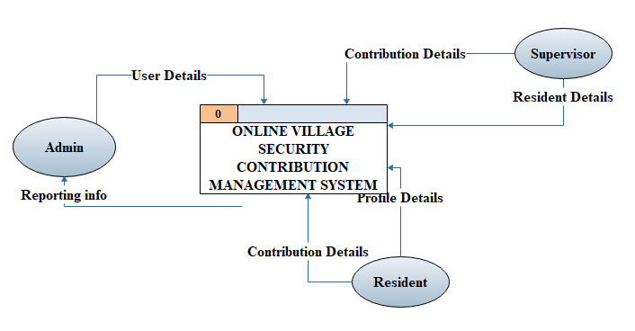

Figure 1: Conceptual framework

**Source:** Researchers, 2019

The figure above which is conceptual frame work is there to show the interaction of users themselves and even with the system.

**Critical review**

In Rwanda most of the population live in rural areas where by 85% of its citizens are in agriculture sector and only 17% of this population are using technologies however the rest are doing it totally manual. This makes any contribution to be given by these cultivators a bit harder since they may not be getting the full amount at the supposed time. This is why it is not questionable to implement a system that allows the residents to pay easily online and allow the administration to make calculations automated instead of getting them from books.

**Proposed System**

All the criticized points in the existing system led to develop an online or a web based platform to payment online management which can be accessed by residents and collector wherever they are, this system is going to provide greater liquidity, reduce time wastage, this system will secure all the activities by recording them in a database, Increase transparency and competition also the work is going to be effective and efficient.

**Summary**

This chapter makes this project more understandable as it gives meaning and concepts of some technical by explaining more keywords in details.

With this chapter have gathered the information and tried get some solutions to solve an existing problem not only that also mentioned the objectives or targets of the study. For this chapter we have got some who tried to make some changes for this study but most of they did not come up with good solution, also chapter shows that it will take only three months of processing including the collection of information.

# CHAPTER THREE: RESEARCH DESIGN METHODOLOGY

## Introduction

Methodology is a system of guidelines for solving a problem, with specific components such as phase, tasks, methods techniques and tools. The methodology includes the methods, procedures, and techniques used to collect and analyze information. In this research, two types of methods used to guide this work are: Techniques of data collection and Software Development Methodology. This section describes briefly the existing system and clarifies the problem caused by this system. In chapter, researcher studies and analyzes the existing system focusing on the process used and also discusses the method to be used for designing the proposed system. (Mitchell, John, 2002)

To develop this system i spent some time studying the existing system, talking to users and finding out how the existing system works and what is required on it by identifying and collecting necessary documentation relating to the system. To achieve this, different data collection techniques have been used and are going to be discussed in this chapter. Further, the Software Engineering Model to be used when developing the proposed system was also discussed. This study merely focuses on developing an VILLAGE SECURITY CONTRIBUTION SYSTEM and this used in the accessing process citizens and providing process of government. The gathered data shall be crucial components in developing the proposed system. The computerized system redeveloped their existing website where prospective people or citizens can view Government related information of different department and different services within the leader who is engaged to that service offered.

## Data collection

Data correction refers to the system that is used to get and arrange the information to be used in the system development, there are different ways to collect information such as documentation, interview, observation but for me I used the below some among all I have said.

### Documentation

Documentation is the process based on reading books, journals and various documents and browsing Internet for searching necessary information related to the topic. This technique exposes the researcher to have a deep knowledge about the existing systems and what is required in the system to be developed. Different documents have been used and contributed to collecting information about the subject of the project topic and what to include in this book. (Dennis, 2012)

### Internet Research

The internet used as a strategy of collecting data; the internet is used by researcher. Search data are used to collect data from the internet; these data involve relatedresearch done by other researchers**.**

### Interview

Interview is a data collection method done by face-to-face conversation or over the telephone between the telephone between the interviewer and interviewee conducted for obtaining information; this method assumes that the interviewee has the required information. The main task in interviewing is to understand the meaning of what the interviewees say. For this project, only the face-to-face interviews were being conducted. (Wixom, 2011)

### Observation

An act of recognizing and noting a fact or occurrence often involving measurement with instruments. Observation also is the active acquisition of information from a primary source. In science, observation can also involve the recording of data via the use of scientific instrument. (Rumbaugh, 2006)

## Software engineering method

The system development life cycle (SDLC) is a conceptual model used in project management that describes the stage involved in information system development project, from initial feasibility study through maintenance of complete application.

There are different types of SDLC such as Waterfall, Spiral, Agile software development, rapid, prototyping, incremental etc…

### The Waterfall Model

The waterfall model of SDLC uses traditional planning, testing, and implementation techniques to design and implement new software products. It represents a sequential development process in which progress is seen as flowing steadily downward through each phase of development.

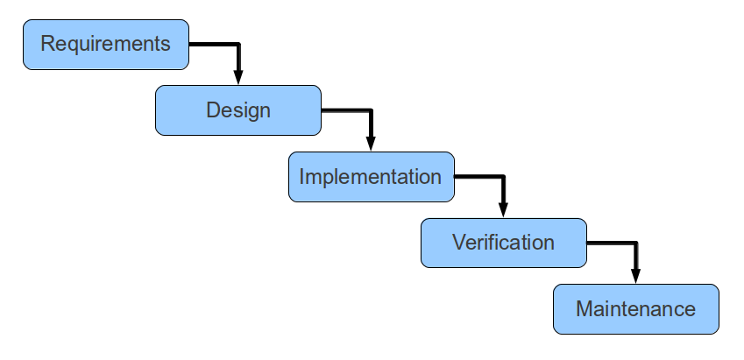

Figure 2: Waterfall model

**Source:** (Pressman, 2011).

The waterfall development model is a product of the manufacturing and development industries where making after-the-fact changes are often prohibitively costly. A development project using this model follows a fixed, linear sequence. Each phase must be completed in its entirety before the next phase can begin. At the end of each phase, a review takes place to determine if the project is on the right path and whether or not to continue the project. An advantage of the waterfall method is that it promotes strong documentation of each step of the development process. Using a waterfall methodology is most likely to be successful when the complexity of the system is low and requirements are static, because there is little room for mistakes and no process for correcting errors after the final requirements are released. This model assumes that the role for users is to specify requirements and that all requirements can be specified in advance. Feedback can be quite limited when using this approach.

The waterfall model has been criticized for its rigidity. Many software developers argue that it is difficult, if not impossible, to finish a phase of a software product’s life cycle perfectly before progressing to the next phase.

The sequential phases in Waterfall model are −

* **Requirement Gathering and analysis** − All possible requirements of the system to be developed are captured in this phase and documented in a requirement specification document.
* **System Design** − the requirement specifications from first phase are studied in this phase and the system design is prepared. This system design helps in specifying hardware and system requirements and helps in defining the overall system architecture.
* **Implementation** − with inputs from the system design, the system is first developed in small programs called units, which are integrated in the next phase. Each unit is developed and tested for its functionality, which is referred to as Unit Testing.
* **Integration and Testing** − All the units developed in the implementation phase are integrated into a system after testing of each unit. Post integration the entire system is tested for any faults and failures.
* **Deployment of system** − Once the functional and non-functional testing is done; the product is deployed in the customer environment or released into the market.
* **Maintenance** − There are some issues which come up in the customer environment. To fix those issues, patches are released. Also to enhance the product some better versions are released. Maintenance is done to deliver these changes in the customer environment.

##### **Advantages of waterfall model**

* Easy to explain to the users.
* Structures approach.
* Stages and activities are well defined.
* Helps to plan and schedule the project.
* Verification at each stage ensures early detection of errors/misunderstanding.

Each phase has specific deliverables.

### When to use the prototyping model:

* Prototype model should be used when the desired system needs to have a lot of interaction with the end users.
* Typically, online systems, web interfaces have a very high amount of interaction with end users, are best suited for Prototype model. It might take a while for a system to be built that allows ease of use and needs minimal training for the end user.
* Prototyping ensures that the end users constantly work with the system and provide a feedback which is incorporated in the prototype to result in a useable system. They are excellent for designing good human computer interface systems.

## SYSTEM SPECIFICATION

System requirements are the configuration that a system must have in order for a hardware or software application to run smoothly and efficiently. Failure to meet these requirements can result in installation problems or performance problems. (Derek H, ‎Imtiaz P, 2013)

### Hardware specifications

Computer hardware specifications are technical descriptions of the computer's components and capabilities.

**Processor**: Intel dual core or above

**Processor speed:** 1GHZ or above

**RAM:** 1 GB RAM or above

**Hard Disk:** 89 GB hard disk or above

**Framework:** Net framework 4.0

### Software Specifications

**MySQL** is a relational database management system (RDBMS), and ships with no GUI tools to administer MySQL databases or manage data contained within the databases. Users may use the included command line tools, or use MySQL "front-ends", desktop software and web applications that create and manage MySQL databases, build database structures, back up data, inspect status, and work with data records. The official set of MySQL front-end tools, MySQL Workbench [is actively developed by Oracle, and is freely available for use.](http://en.wikipedia.org/wiki/MySQL#cite_note-29)

(Andrew C, ‎Stephen B, 2015)

**Web server APACHE**: Apache is the most widely used web server software. Developed and maintained with apache software foundation. Apache is an open source software available for free it runs on 67% of all web servers in the world it is fast reliable and secure

(Rich B ‎Ken C, ‎Richard B, 2008)

**Backup Restore Software** The backup restore is software that is used to backup data that reside either locally or remotely to a form of media that can then be used to restore data if necessary. Backup-restore software is implemented either on a local server or used as an enterprise solution to backup many servers. The server does not have to be stopped to do a backup, web based work with any back-up software appropriate to the operating system.

**(**Steven N, 2011)

**A computer**: A computer is an electronic device which is capable of receiving information (data) in a particular form and of performing a sequence of operations in accordance with a predetermined but a variable set of procedural instructions (program) to produce a result in the form of information or signals. (David L, 2013)

**Database normalization:** Database normalization is the process of organizing the fields and tables of a relational database to minimize redundancy. Normalization usually involves dividing large tables into smaller (and less redundant) tables and defining relationships between them. The objective is to isolate data so that additions, deletions, and modifications of a field can be made in just one table and then propagated through the rest of the database using the defined relationships.( Jesse R, ‎Ronald C,2012)

## SYSTEM REQUIREMENT

## Functional Requirements

There are two internal users involved in this system. The functional requirements are considered as follows:

**Resident**

1. To be able to view their contributions records, including when they paid last and due payments.

2. To be able to view and update their personal information, including name, contact address, and phone number, to keep their information record up to-date.

3. To be able to find tariffs and pay online using paypal.

**Administrator/ Village**

1. To be able to create, remove and query resident’s records in order to manage residents’ information.

2. To be able to create and retrieve payment records to manage information about contributions made.

3. To be able to record and retrieve the village’s contributions plan

4. To be able to send SMS to residents for their user account and any concerned contribution through the system.

### Non-functional requirements

Non-functional requirement (NFR) defines system attributes such as security, reliability, performance, maintainability, scalability, and usability. They are contrasted with functional requirements that define specific behavior or functions.

* The system will be compatible with Windows Operating Systems.
* The system is user-friendly and provides a simple interface for the user.
* The information of the system should be stored in the database.
* The system will be reliable and all of its functions shall perform as required.
* The system will respect ethical rules and regulations.
* **Performance**: The system is expected to have reasonable short time response. Users should be able to login and able to get response for their request.
* **Security**: All passwords that are generated or accepted must be stored in database in an encrypted form.
* **Usability**: The system will have the good user interface with more interactive forms and menus that make the system usable to system users.
* **Reliability**: The system will operate every day, and every hour while ensuring that information is delivered on time as required.
* **Accessibility**: users can access their results from any location (as long as they are within a network service reception area).

## SYSTEM DEVELOPMENT ANALYSIS AND DESIGN

Online Village Security Contribution system is a system study done on village level with aim of maintaining the records of residents, allowing them to pay hence managing those details of contributions on a resident perspective. They record on paper all collection service that they do which is tiresome to find a specific resident while making any service, again this current system may lead to easily loss of data since are recorded on the papers hence delay of services. The user of the systems is manager who’s the leader of the village administration, the resident and collector. Resident and manager are assumed to have basic knowledge of computer. While collector of the contribution should have more knowledge so they can resolve small problem and perform information. The user manual, installation guide and other related material should be sufficient to educate the user how to use and maintain the system.

## CONTEXT (LEVEL 0) DIAGRAM

A context level DFD is the most basic form of DFD. it aims to show how the entire system works at glance. There is only one process in the system and all the data flows either into or out of this process. Context level DFD’s demonstrates the interactions between the process and external entities. They do not contain data stores. (Jesse R, ‎Ronald C – 2012)

**Example of context diagram**

When drawing context level DFD’s, we must first identify the process, all the external entities and all the data flow. It is advised that we draw the process in the middle of the page. We then draw our external entities in the corners and finally connect our entities to our process with the data flows.



## CONTEXT (DFD LEVEL 1) DIAGRAM

This figure which is DFD Level 1 is the breakdown of Level 0 into more clear parts to show the interaction of users themselves and even with the system, here the way data from users to the system and into their store even from store to be used.

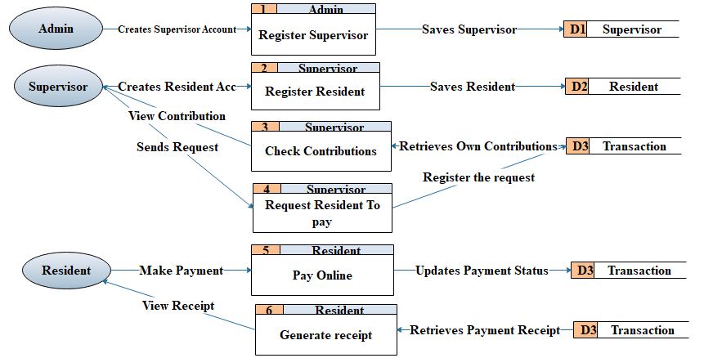

## ENTITY RELATIONSHIP DIAGRAM

**Entity-Relationship Diagrams** (ERDs) are another way of showing information flow for a process. An ERD shows what data is being used in the process or program, and how the files are related. The E-R (entity relationship) data model views the real world as a set of basic objects (entities) and relationships among these objects. It is intended primarily for the database design process by allowing for the specification of an enterprise scheme. This enterprise scheme represents the overall logical structure of the database. ERDs do not show any program functions, nor data flow. (Itzik B, ‎Adam M, ‎Dejan S, 2015)

### Entity relationship diagram symbols

**Entity**

An **entity is** the concept used for things recognized as

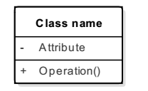

Figure 5: Entity relationship diagram symbols

Being capable of independent existence that is uniquely identified. Entities are often the names of those things such as a computer, an employee, a customer or a supplier. Entities are represented in ER diagrams by a rectangle and named using singular nouns.

Figure 6: Entity



**2. Attributes**

Each entity has **attributes** or characteristics which describes that entity. A key attribute is the unique distinguishing characteristics of the entity. For instance, a supplier name or supplier number would be an attributes that describe the entity supplier.

1. **Relationship**

Relationships are defined as being the data shared between the entities. A relationship captures how two or more entities are related to one another, as well as how they are joined together. Relationships are represented by diamond shapes and are labeled using verbs.

Figure 8: Relationship



**Cardinality**

Describes how many entity instances can be in the relationship. The followings are types of cardinality.

One-to-one [1:1]

One-to-many [1:N]

Many-to-many [M:N]

**Cardinality:** Cardinality specifies how many instances of an entity relate to one instance of another entity. (Itzik B, ‎Adam M, ‎Dejan S, 2015)

**Ordinarily**: is also closely linked to cardinality. While cardinality specifies the occurrences of a relationship, ordinarily describes the relationship as either mandatory or optional. In other words, cardinality specifies the maximum number of relationships and ordinarily specifies the absolute minimum number of relationships. Entity Relationship Diagram for Staff Shift management. (Itzik B, ‎Adam M, ‎Dejan S, 2015)

### ENTITY RELATIONSHIP DIAGRAM

It is defined as data modeling technique that creates a graphical representation of the entities, and the relationships between entities, within an information system.

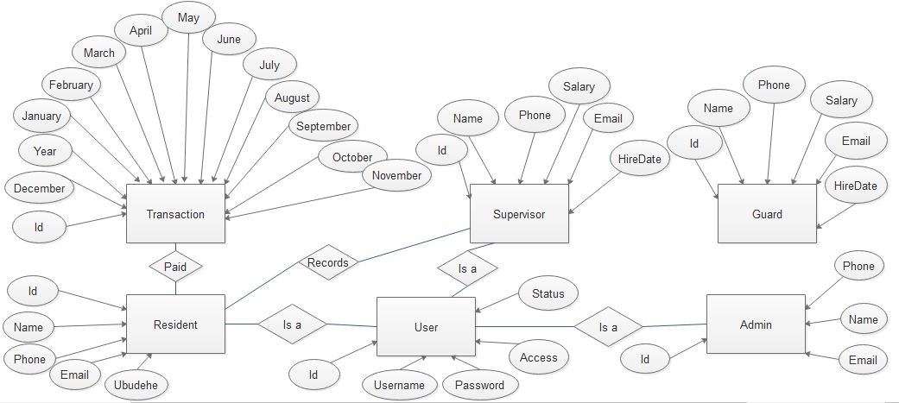

Figure 9: Entity relationship diagram

## PHYSICAL DATA MODELING

This model diagram illustrates the organization of data in the database that stores data for the database system. It describes all the details and the relationship between the tables that make up the database.

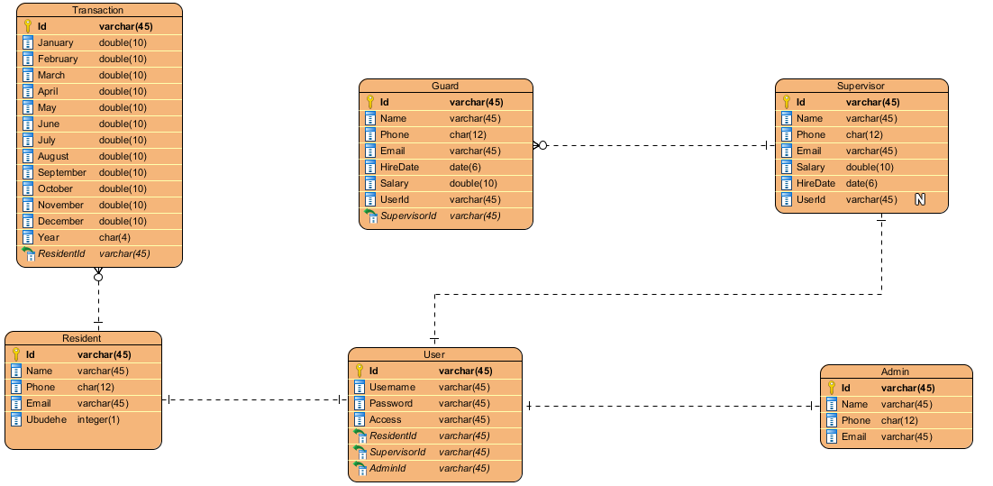

Figure 10: Physical data modeling

## DATA DICTIONARY

A data dictionary is an integral part of a database. It holds the database and the data structure.

|  |  |  |
| --- | --- | --- |
| **User** | | |
| **Field** | **Type** | **Integrity** |
| User_ID | varchar(20) | Primary key |
| Username | varchar(50) | Not null |
| Password | varchar(50) | Not null |
| Access | Varchar(50) | Not null |
| Status | Varchar(50) | Not null |
| **Admin** | | |
| **Field** | **Type** | **Integrity** |
| Admin_ID | varchar(20) | Primary key |
| Name | varchar(50) | Foreign key |
| Phone | Char(10) | Not null |
| Email | Varchar(50) | Not null |
| **Transaction** | | |
| **Field** | **Type** | **Integrity** |
| transaction_Id | varchar(20) | Primary key |
| january | double(10) |  |
| february | double(10) |  |
| march | double(10) |  |
| april | double(10) |  |
| may | double(10) |  |
| june | double(10) |  |
| july | double(10) |  |
| August | double(10) |  |
| september | double(10) |  |
| October | double(10) |  |
| November | double(10) |  |
| December | double(10) |  |
| year | Int(5) | Not null |
| **Resident** | | |
| **Field** | **Type** | **Integrity** |
| Resident_Id | Varchar(50) | Primary Key |
| Name | Varchar(50) | Not null |
| Email | Varchar(20) | Not null |
| Phone | char(10) | Not null |
| **Supervisor** | | |
| **Field** | **Type** | **Integrity** |
| Supervisor_Id | varchar(20) | Primary Key |
| Name | Varchar(50) | Not null |
| Phone | Char(10) | Not null |
| Email | Varchar(50) | Not null |
| HireDate | Date(6) | Not null |
| salary | Varchar(50) | Not null |
| **Guard** | | |
| **Field** | **Type** | **Integrity** |
| Guard_Id | Varchar(20) | PrimaryKey |
| Name | Varchar(50) | Not null |
| Phone | Char(10) | Not null |
| Email | Varchar(50) | Not null |
| Salary | Double(10) | Not null |
| HireDate | Date(6) | Not null |

Table 1: Data Dictionary

## **TOOLS AND LANGUAGES TO BE USED IN SOFTWARE DEVELOPMENT**

The tools and languages to be used include:

**MySQL:** is an open source relational database management system. It is based on the structure query language (SQL), which is used for adding, removing, and modifying information in the database. Standard SQL commands, such as ADD, DROP, INSERT, and UPDATE can be used with MySQL. MySQL can be used for a variety of applications, but is most commonly found on Web servers (Aronson, 2016)

**SQL (Structured Query Language):** is a set of commands or query language use for accessing and maintaining data store in database. By using SQL, we can insert, edit, delete or update information stored in database. SQL is the most powerful database language used to get date into or back from database. (Petri, Jürgen, 2012)

**XAMPP:** is a free and open source cross-platform web server solution stack package developed by **Apache Friend** consisting mainly of Apache HTTP server, MYSQL database, and interpreter for scripts written in JAVA and Perl programming languages. XAMPP issued as a development tool to allow website designers and programmers to test their work on their own computer without any access to Internet. It also provides a support for manipulating databases in MQSQL. (Taft, 2005)

**HTML stands for Hypertext Markup Language (HTML):** is the special markup language used to create web pages. It is a set of codes inserted in a file intended for display on a World Wide Web browser page. HTML is written in the form of HTML elements consisting of tags. Those web pages are read by using web browsers. HTML allows images and objects to be embedded and it is used to create interactive forms. (Beizer, Boris, 2009)

**JAVA:** is a scripting language that is usually embedded or combined with the HTML (Hypertext Markup Language) of a web page. is a general scripting language that was originally designed for dynamically web development.  JAVA allows web developers to create dynamic content that interacts with databases. For this purpose, JAVA code is embedded into the HTML source document. (Maccalister, 2015)

**CSS**: stand for cascading style sheet file, it allows you to separate your web sites HTML content from its style. As always you use your (X) HTML file to arrange the content, but all of the presentation (fonts, colors, background, borders, text formatting, link effects & so on...) are accomplished within a CSS. (Etemad, 2015)

**Adobe Dreamweaver:** is a web design software program you can use to create and edit pages for display on the World Wide Web. (Lowagie, 2007)

**Adobe Photoshop:** is photo-editor and design software. It is a raster graphic editor developed and published by Adobe Systems for Windows and OS X. When designing graphics for this project, we use Adobe Photoshop CS4 (Creative Suite 4) which is very easy to use for a complete beginner. (Vaughan-Nichols, 2013)

**Browser:** is a software program that allows a person to explore the Internet in an easy way. It helps in navigating the Internet through a series of links. Example of popular browsers: Google Chrome, Internet Explorer, Mozilla Firefox, Safari, and Opera. (Ford, 2017)

Access the government service paid and free service and leader give them an appointment to the requested services instead of going to take a time to the office waiting to meet with a leader. (Proper, 2015)

# CHAPTER FOUR: SYSTEM ANALYSIS, DESIGN AND IMPLEMENTATION

## Introduction to the study

Online Village Security Contribution system is a system study done on Village level with aim of maintaining the records of residents, paying online and automating calculation details.

## The system study

### Weakness observed in the current system

They record on paper all contribution service that they do which is tiresome to find a specific resident or any other need while making any service, takes long time to reach the collector to pay and again this current system may lead to easily loss of data since are recorded on the papers hence delay of services.

## System analysis

### User requirement of the proposed system

The user of the systems is manager who is the leader of the village administration, the resident and collector.

Resident and manager are assumed to have basic knowledge of computer. While collector of the contribution should have more knowledge so they can resolve small problem and perform information.

The user manual, installation guide and other related material should be sufficient to educate the user how to use and maintain the system.

### Functional requirement

The software must allow creation of user accounts by administrator and secured access at, and from data streaming real-time monitoring services.

The project must request username and password for access to data, only after authentication will allow access to the system

The project must not allow resident any access to the system so far

The project must provide the request registration by client.

The system gives privileges of check resident contribution details to all users of the system

System gives mean of create account of resident, this is done by collector.

The software to be developed must operate without interruption twenty-four hours a day

The software must retrieve, update, and store data from multiple input.

The software must allow full and complete record search queries by users

### Non-functional requirements

Non-functional requirement (NFR) defines system attributes such as security, reliability, performance, maintainability, scalability, and usability. They are contrasted with functional requirements that define specific behavior or functions.

For example: The software interface must allow design conventions which for familiar location of menus, etc.

Input error will be returned in red with appropriate message box.

System should automatically update after every service.

### System Requirement

System requirements are the configuration that a system must have in order for a hardware or software application to run smoothly and efficiently. Failure to meet these requirements can result in installation problems or performance problems.

### Requirement specification

Requirements specification in engineering refers to specific design requirement(s). In software engineering, it is a result of a requirements analysis and can refer to.

### Software specification

Programming language: JAVA

Database: MySQL

Reporting tools: iText

1. **Hardware requirements specification**

**Processor**: Intel dual core or above

**Processor speed:** 1GHZ or above

**RAM:** 1 GB RAM or above

**Hard Disk:** 89 GB hard disk or above

**Framework:** Net framework 4.0

## Systems Design

### Overview

Systems design is the process of defining the architecture, modules, interfaces, and data for a system to satisfy specified requirements. Systems design could be seen as the application of systems theory to product development. There is some overlap with the disciplines of systems analysis, systems architecture and systems engineering.

### Database Diagram

A **database schema** of a database system is its structure described in a formal language supported by the database management system (DBMS) and refers to the organization of data as a blueprint of how a database is constructed (divided into database tables in case of Relational Databases. The formal definition of database schema is a set of formulas (sentences) called integrity constraints imposed on a database. These integrity constraints ensure compatibility between parts of the schema. (Proper, 2015)

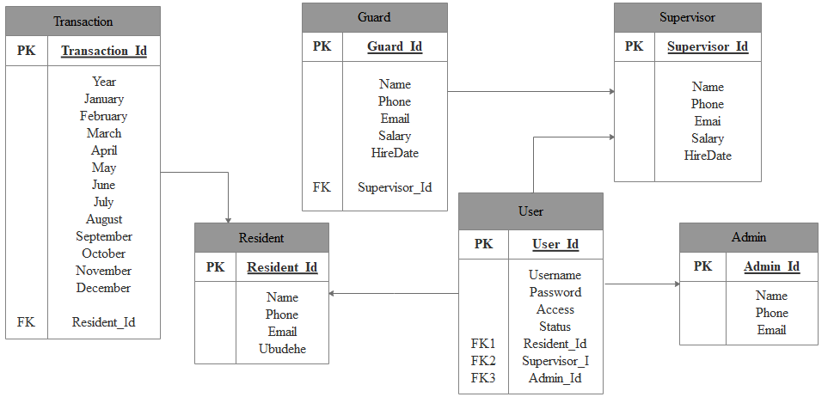

Figure 11: Database Diagram

## System implementation

### Screenshots

**Login page**



Figure 12: Login Page

This is the view any user of the system get when login in the system whereby the system requires a user to login with his or her username and password accordingly.

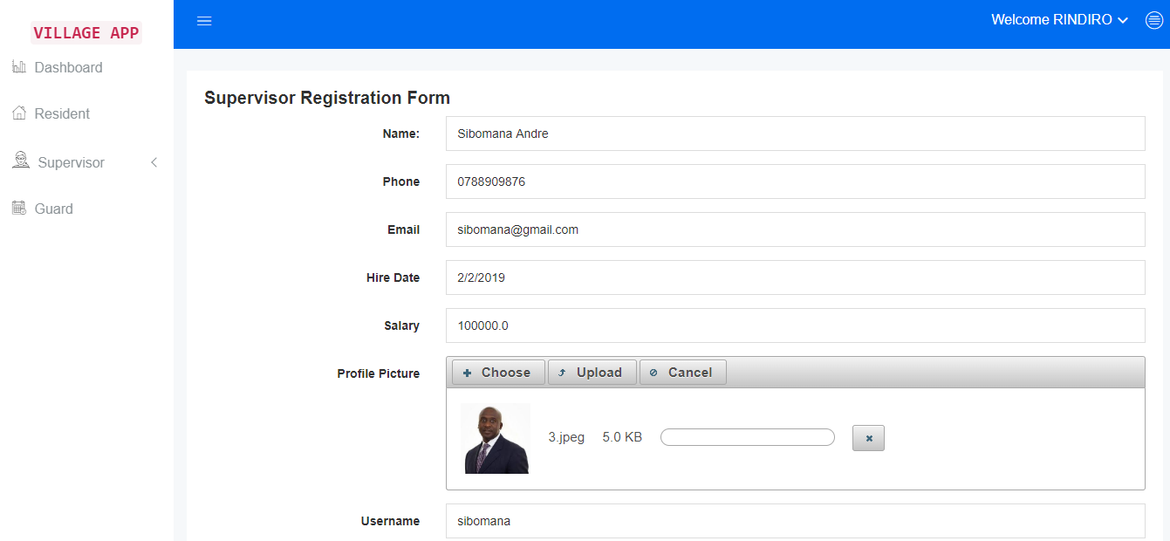

**Figure 12: Add Supervisor**

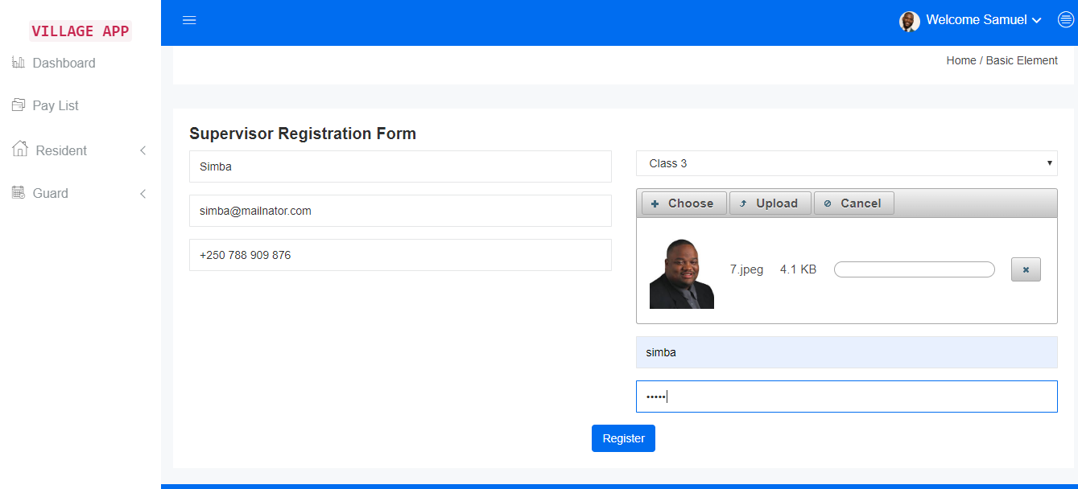

**Figure 13: Add Resident**

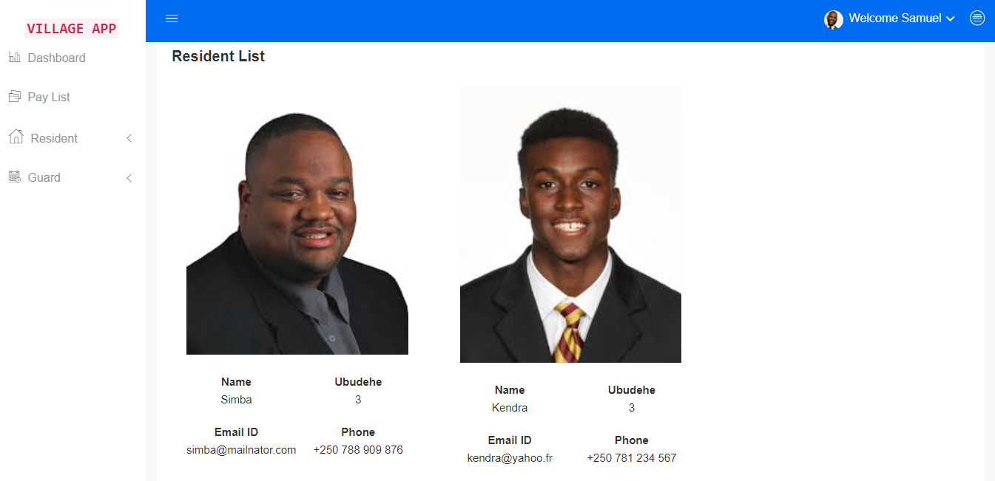

**Figure 14: Residents List**

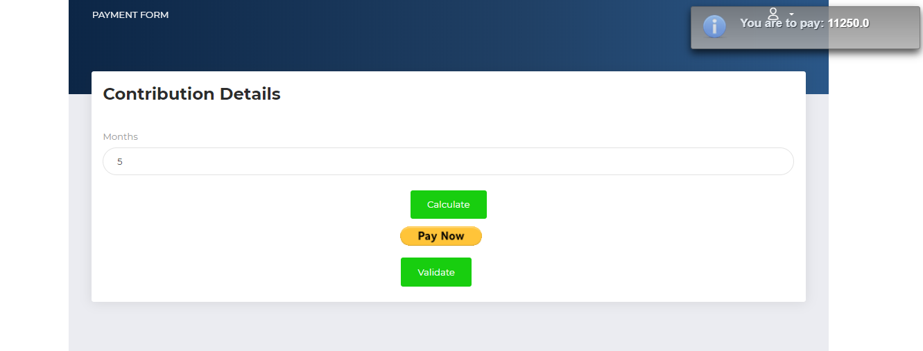

**Figure 15: Resident Pay**

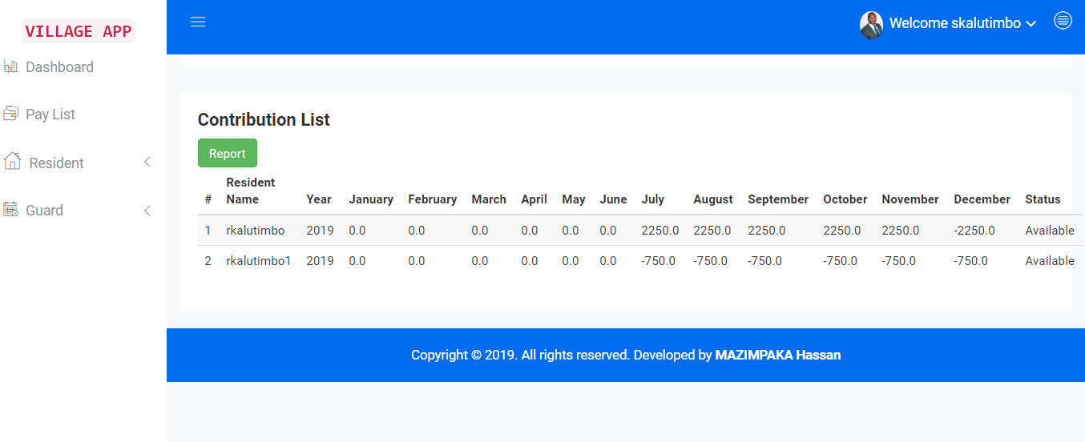

**Figure 16: Payment List for Supervisor**

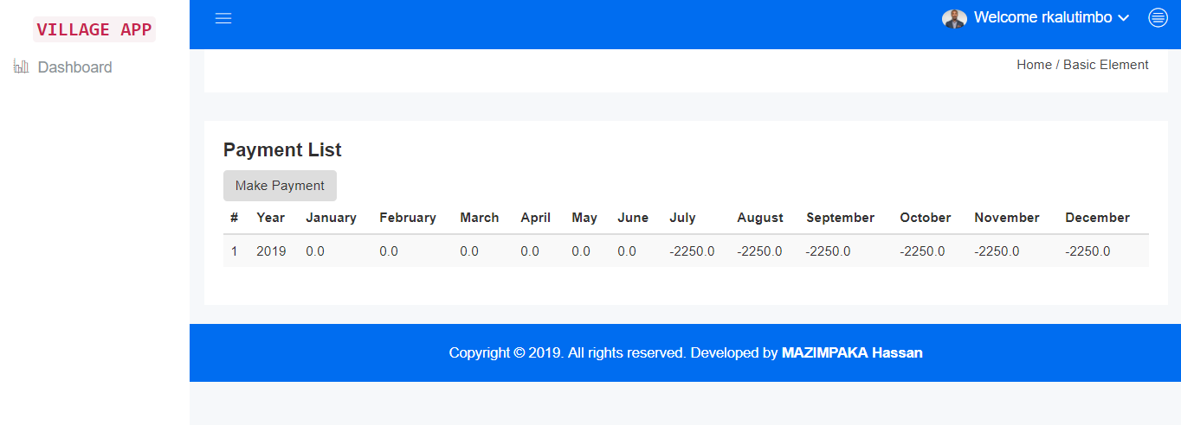***Figure 17: Payment List of a Resident***

## System testing

* Ultimately, the software is incorporate with other system element (eg: hardware, people, information) and a series of system integration and validation tests are conducted.
* System testing is actually a series of different tests whose primary purpose is to fully exercise the computer based system
* After implementation the system all the flow of data between interfaces are done or not.

## Validation

* In validation testing first of all we have check that all requirements which were given for administration like balance is fulfilled or not.
* All the requirements which were given for user side (means viewing new information comparison of two model) appropriately done or not.

## 

## CHAPTER FIVE: DISCUSSION, CONCLUSION AND RECOMMENDATION

## Discussion

This system, is Online Village Security Contribution Management System, it is just a contribution payment system. It is accessed with login form where the login can identify if the user of the system is a resident or other user of the system. The system has different users (manager, collector and Resident), when user accessing the system as a village manager he has right to create the account of the village and setting the monthly payment of that particular village; when accessing the system as the user (collector) he has only the right to create residents’ account, check the status of resident payment. When the user accessing the system as the user (resident) he has only the right of making payment based on ubudehe for due months. But when user accessing the system as a village manager he has right to view the report of the contributions given by the residents.

## Conclusion

By using “Online Village Security Contribution Management system”, the service can be easily monitored and the report acts as a proof. The services were taken systematically and saved safely in the database rather than manually through paper work. It requires less time and space to save the services details. Database can be cleared yearly or monthly and easily get information about the customers. Not only saying on behalf of security contribution system, in general online payment based on computer system makes services easier, faster and secure.

## Recommendation

Based on the results of the finding and conclusions gathered, i would like to recommend the following

### to Village in Rwanda

This recommends that each village consider the proposed system for them to deliver good services to their residents.

### To University of Kigali

The recommendation to university of Kigali is to provide that future researchers should continue to improve the proposed system. Also recommend University of Kigali to give us more practical work for increase the practical skills of students. And another recommendation Students of University of Kigali are to put more effort in cooperation because sharing ideas may lead to the increase of programming skills

### To the Researcher

I recommend the other researchers to complete all what I have not yet implemented such as the way manager can access service. In closing this work, I would like to suggest any interested person can add other functions to improve my work in order to improve Village security contribution Management System. For this system we recommend the future researchers to work on modules related to cleaning services payment at village level.